Referee Badge Level
Upgrade Process

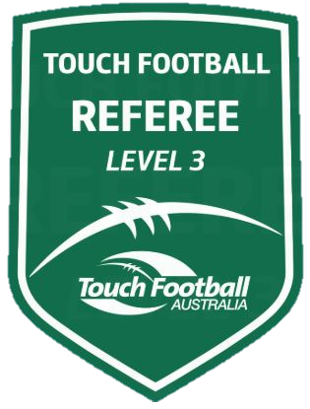

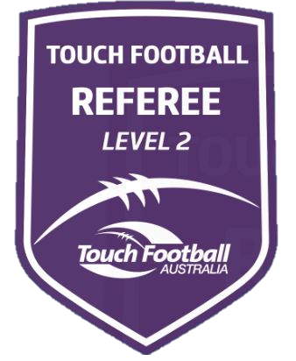
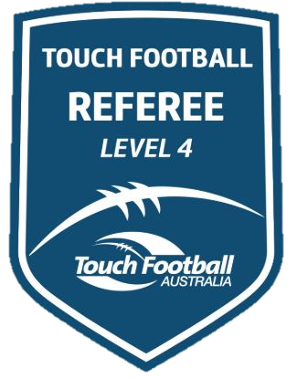

The State Cup is the haven for referees to achieve a badge Level upgrade. There will be panel in place to assess and coach referees toward Level 3 and Level 4 Badge upgrades. These will be announced at the Saturday night function.

Regional Referee Directors will also be completing assessments toward Level 2 badge upgrade. These will be announced on Sunday morning in the Referee Tent. TTBA.

Level 3 Badge Upgrades
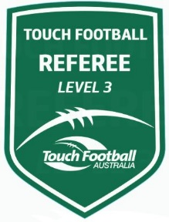
An opportunity exists for Referees, who have attended the Level 3 Course and passed the Level 3 Examination, to be upgraded to Level 3. Nominations for this Level must be made through and endorsed by your Regional Director of Referees and must be received fourteen (14) days prior to the State Cup. The State Level 3 Upgrade team must have these nominations before upgrade will be made. Upgrades will be announced at the Saturday night function. Referees Panel Members will be completing the TFA Level 3 Referees checklist for nominated Referees.
These sheets will be available on request by the referee. At this stage panel members, will be available to discuss the contents of these sheets and provide you with direction for the future, whether or not you have been successful with an upgrade.
To be nominated for a Level 3 Upgrade, you must have the endorsement of your Regional Referees Director, they are;

Rebels Greg Myers 0418 229 953
Scorpions Bill Slade 0402 313 852
Mets Victor Baptista 0434 155 886
Hornets Amanda Draper 0427 482 706
Suns Peter Millington 0417 256 161
Eagles Phil Rainger 0427 412782

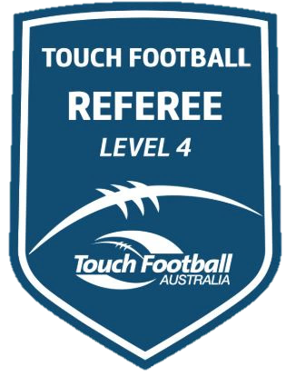
Level 4 Badge Upgrades
The opportunity also exists for referees to be elevated to Level 4 status. The State Cup is the one and only event from which this grade is achievable. Upgrade will be made based on twelve-month consistent performance.

Consideration points are;
- Attendance at regional tournaments
- Attendance at two (2) NSWTA tournament as a minimum in a calendar year. One MUST be the State Cup
- TID by State Referees Panel at NSWTA and TFA events
- Commitment to affiliate refereeing
- Course Presentations
- On Field Performance

At the past State Cup Events we have been able to announce these on the Saturday night. We are shooting toward this again, but there is no guarantee as we need to be accurate with this and we also need to have the names of the successful referees, ratified by the NSWTA Board of Directors.

Upgrade Procedure for the NTL Series.

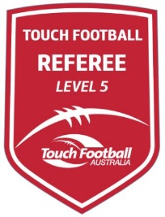
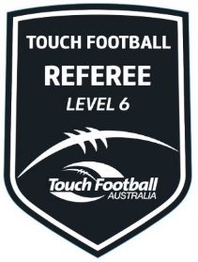
Upgrade to

Level 5 or Level 5 and Level 6 Badge. Referees seeking this level will be evaluated using the below criteria;

- Recommendation from the NSWTA Referees Panel
- Endorsement by the NSWTA Board
- TID by State Referees Panel at NSWTA and TFA events
- Commitment at Affiliate and Regional level in both Refereeing, Referee Coaching and Mentoring.
  - Referees should hold the Foundation Referee Coaching Course Qualification
- Course Presentations

A list of “Possible and Probable” referees as determined by the NSWTA Referees Panel using the above criteria and will be submitted to the TFA Upgrade Lead (Ken Golden)

Referees will be appointed into the appropriate category games. (Open or Senior Category)

Evaluation will be completed during these games using the TFA Referee Checklist for that level.

Referees will be advised of their status at the NSWTA State Cup by the personnel responsible for this portfolio.

Selection of State Squad Referees (NTL Representation)

Below is a direct excerpt from the NSWTA Referees Policy

Potential State Squad Referees will be assessed over a period of twelve (12) months at NSWTA tournaments, by the State Referees Panel.

These assessments will be collated by the State Director of Referees, and maintained in an individual personal file.

Selection will be based on performances during the year and commitment to affiliate and regional level. Verification may be sought from the Regional Director of Referees. Squad numbers will depend on the amount assigned to NSWTA by TFA. Final names will be selected, with the remaining names placed in order and submitted to TFA.

All squad members must be endorsed by the NSWTA Board of Directors

NB. To be considered for State Squad selection (National Representation) the referee must have attended at least two (2) state Level tournaments during the twelve (12) month period leading to nomination for final selection. One of these must include the NSWTA State Cup.

Dispensation may be sought only in extenuating circumstances. Any request for dispensation must be in writing to the NSWTA Director of Referees.

The following pages contain Checklist for Level 3 Badge and above.

Game Awareness and Positioning | NYC | C
Demonstrates a good knowledge of attack strategy, and positions accordingly in general play
Keeps "eyes on the ball" and moves with the ball to be in the next desired position |  | *
Is aware of and manages loose players well
Checks both sides for shooter(s), manages and communicates appropriately
Has a physical presence in the 5m line |  | *
Sets the 5m line consistently |  | *
Sprints the change of possession (i.e. 5 m to 5 m) |  | *
Game Management
Manages the “defensive player who makes the touch” to an on-side position well and at the appropriate time
Consistently manages/controls the roll ball (no interference)
Manages the defensive players on the 5m and 10m (following the tap) |  | *
Played some advantage through pro-active/early communication to keep game flowing
Manages physical play and takes appropriate action as and when necessary |  | *
Identifies and manages verbal conflict appropriately and with confidence
Clear, concise signals, whistle and explanations given with and for decisions so off-field referees can react quickly and set up the defensive line |  | *
Is not over officious or over referee the game with pedantic rulings
Establishes clear and audible communication with players |  | *
Displays an adequate knowledge of the rules and their application to the game |  | *
Teamwork and Communication
Sets a 5m line reference point from off field position consistently |  | *
Provides support to on-field referee
Builds a rapport with wingers and links to enhance teamwork |  | *
Communicates with realigning players (defenders) to assist on-field referee with 5m control.
Communicates with the on field referee to keep players moving forward, off the scoreline
Is supportive and in sync with referee team decisions |  | *
Adopts appropriate off field positions to assist with decision making
Referee Systems
Interchanges made with confidence |  | *
Communicates well on field entry |  | *
Demonstrates appropriate field entry positioning and establishes the 5m line early/quickly
Demonstrates an awareness of the sub box and manages players if required
Exits field at an angle to ensure the oncoming referee can take early control
On exit maintains game awareness to ensure management of any incident/assist on-field referee |  | *
Score line
Is close to Touchdown situations and has a clear view of the ball and touches at and behind the scoreline |  | *
Demonstrates a knowledge of attack strategy, and positions accordingly on scoreline
Responds to the long ball, moves accordingly to maintain sight and good proximity to the ball
Manages defenders within 5m of the scoreline (standoff) well
Assessors Note: To be deemed competent a referee needs competency in all areas marked (*) above.
Competent

Not yet competent

Feedback Referee is of the standard to be upgraded to Level 3
The referee requires further experience/skills in the following areas:……………………………………………………………………………….

Game Awareness and Positioning | NYC | C
Demonstrates a sound knowledge of attack strategy, and positions accordingly in general play |  | *
Keeps "eyes on the ball" and anticipates the play to be in the next desired position |  | *
Is aware of and manages loose players consistently
Checks both sides for shooter(s), manages and communicates appropriately
Has a physical presence in the 5m line |  | *
Sets the 5m line consistently, |  | *
Anticipates the change of possession and sprints the change of possession (i.e. 5 m to 5 m) |  | *
Game Management
Manages the “defensive player who makes the touch” to an on-side position well and at the appropriate time
Consistently manages/controls the roll ball (no interference) |  | *
Manages the defensive players on the 5m and 10m (following the tap), manages off side players in drives, is aware of player prioritisation
Plays advantage through pro-active/early communication to keep game flowing |  | *
Manages physical play and takes appropriate action as and when necessary |  | *
Identifies and manages verbal conflict appropriately and with confidence
Clear, concise signals, whistle and explanations given with and for decisions so off-field referees can react quickly and set up the defensive line |  | *
Is not over officious or over referee the game with pedantic rulings
Establishes clear and audible communication with players |  | *
Displays a detailed understanding of the rules and their application to the game |  | *
Teamwork and Communication
Consistently sets a 5m line reference point from off field position |  | *
Provides good support to on-field referee
Builds a good rapport with wingers and links to enhance teamwork |  | *
Communicates with realigning players (defenders) to assist on-field referee with 5m control. |  | *
Communicates effectively with on field referee to keep players moving forward, off the scoreline
Is supportive and in sync with referee team decisions, demonstrates appropriate leadership |  | *
Adopts very good off field positions to assist with decision making |  | *
Referee Systems
Interchanges made with confidence, shares the game workload, initiates the interchanges |  | *
Communicates effectively on field entry, uses options to eliminate penalties on entry |  | *
Demonstrates good field entry positioning, uses short side if appropriate, establishes the 5m line early/quickly |  | *
Aware of player rotation from the sub box and reacts accordingly to eliminate game chase
Exits field at an angle to ensure the oncoming referee can take early control
On exit maintains game awareness to ensure management of any incident/assist on-field referee |  | *
Score line
Is close to Touchdown situations and has a clear view of the ball and touches at and behind the scoreline, is aware of set plays and is well positioned for all scoring opportunities |  | *
Demonstrates a good knowledge of attack strategy, and positions accordingly on scoreline
Anticipates the long ball, moves accordingly to maintain sight and good proximity to the ball |  | *
Effectively manages defenders within 5m of the scoreline (standoff)
Assessors Note: To be deemed competent a referee needs competency in all areas marked (*) above.
Competent

Not yet competent

Feedback Referee is of the standard to be upgraded to Level 4
The referee requires further experience/skills in the following areas:……………………………………………………………………………….
………………………………………………………………………………………………………………………………………………………………

Game Awareness and Positioning | NYC | C
Demonstrates a very good knowledge of attack strategy, and positions accordingly in general play |  | *
Anticipates the play to be in the next desired position, moves with urgency, uses full field width |  | *
Is aware of and manages loose players consistently and supports buddies calls |  | *
Demonstrates a good knowledge of the player’s roles and the impact on game outcomes
Checks both sides for shooter(s), manages appropriately and communicates early |  | *
Has a physical presence in the 5m line where game strategy allows |  | *
Sets the 5m line consistently, utilising appropriate movement techniques and communications |  | *
Anticipates the change of possession and sprints the change of possession (i.e. 5 m to 5 m) |  | *
Game Management
Manages the “defensive player who makes the touch” to an on-side position early and allows game to flow |  | *
Consistently manages/controls the roll ball (no interference) with forethought for advantage |  | *
Manages the defensive players on the 5m and 10m (following the tap)
Manages the off side players in drives, is aware of referee prioritising (where referee has to focus and with the buddies recognising that)
Plays advantage through pro-active/early communication to keep game flowing |  | *
Manages physical play and takes appropriate action as and when necessary, early where possible |  | *
Identifies and manages verbal conflict appropriately and with confidence
Clear, concise signals, whistle and explanations given with and for decisions so off-field referees can react quickly and set up the defensive line. Signal and decision given toward the defence |  | *
Establishes clear and audible communication with players |  | *
Displays a detailed understanding of the rules, their application and impact on the game |  | *
Teamwork and Communication
Consistently sets a 5m line reference point from off field position and still maintains a clear view of the on field referee |  | *
Provides effective support to on-field referee
Builds a very good rapport with wingers and links to enhance teamwork |  | *
Communicates with realigning players (defenders) to assist on-field referee with 5m control and advantage |  | *
Communicates effectively with on field referee to keep players moving forward, off the scoreline |  | *
Is supportive and in sync with referee team decisions, demonstrates appropriate leadership |  | *
Adopts very good off field positions to assist with decision making |  | *
Referee Systems
Interchanges made with confidence, shares the game workload, is in a change position and initiates the interchanges |  | *
Communicates very effectively on field entry, uses options to eliminate penalties on entry, positive influence on the game |  | *
Demonstrates good field entry positioning, uses short side if appropriate, establishes the 5m line early/quickly, square before the first touch is made |  | *
Aware of player substitutions, game strategies at the substitution and responds accordingly
Exits field at an angle to ensure the oncoming referee can take early control |  | *
On exit maintains game awareness to ensure management of any incident/assist on-field referee |  | *
Score line
Is close to Touchdown situations and has a clear view of the ball and touches at and behind the scoreline, is aware of set plays and is well positioned for all scoring opportunities |  | *
Demonstrates a very good knowledge of attack strategy, and positions accordingly on scoreline
Anticipates the long ball, moves accordingly to maintain sight and good proximity to the ball |  | *
Effectively manages defenders within 5m of the scoreline (standoff) |  | *
Assessors Note: To be deemed competent a referee needs competency in all areas marked (*) above.

Not yet competent
Competent
Feedback Referee is of the standard to be upgraded to Level 5
The referee requires further experience/skills in the following areas:………………………………………………………………………………………...

Game Awareness and Positioning | NYC | C
Demonstrates an excellent knowledge of attack strategy, and positions accordingly in general play |  | *
Consistently anticipates the play to be in the next desired position, moves with urgency, uses full field width |  | *
Is aware of and manages loose players consistently |  | *
Demonstrates a very good knowledge of the player’s roles and the impact on game outcomes |  | *
Consistently checks both sides for shooter(s), manages appropriately and communicates early |  | *
Has a consistent physical presence in the 5m line where game strategy allows |  | *
Sets the 5m line consistently, utilising appropriate movement techniques and communications |  | *
Anticipates the change of possession and sprints the change of possession (i.e. 5 m to 5 m) |  | *
Game Management
Manages the “defensive player who makes the touch” to an on-side position effectively and early |  | *
Is aware of the need to ensure 5m distance between attack and defence, does not accept the roll of the defensive line |  | *
Manages the defensive players on the 5m and 10m (following the tap) |  | *
Manages the off side players in drives, is aware of player prioritisation |  | *
Plays advantage through pro-active/early/effective communication to keep game flowing |  | *
Manages physical play and takes appropriate action as and when necessary, early where possible |  | *
Identifies and manages verbal conflict appropriately and with confidence |  | *
Clear, concise signals, whistle and explanations given with and for decisions so off-field referees can react quickly and set up the defensive line, clear and audible communication with players |  | *
Effectively manages the pocket defender and keeps player in the game |  | *
Displays a detailed understanding of the rules, their application and impact on the game |  | *
Teamwork and Communication
Consistently sets a 5m line reference point from off field position |  | *
Provides consistent and very effective support to on-field referee |  | *
Builds an effective rapport with wingers and links to enhance teamwork |  | *
Communicates very effectively with realigning players (defenders) to assist on-field referee with 5m control and advantage |  | *
Communicates very effectively with on field referee to keep players moving forward, off the scoreline |  | *
Is supportive and in sync with referee team decisions, demonstrates appropriate leadership |  | *
Adopts excellent off field positions to assist with decision making |  | *
Referee Systems
Interchanges made with confidence, shares the game workload, initiates the interchanges |  | *
Communicates very effectively on field entry, uses options to eliminate penalties on entry, positively influences player actions |  | *
Demonstrates good field entry positioning, uses short side if appropriate, establishes the 5m line early/quickly, square before the first touch is made |  | *
Aware of player substitutions, game strategies at the substitution and responds accordingly |  | *
Exits field at an angle to ensure the oncoming referee can take early control |  | *
On exit maintains game awareness to ensure management of any incident/assist on-field referee |  | *
Score line
Is close to Touchdown situations and has a clear view of the ball and touches at and behind the scoreline, is aware of set plays and is well positioned for all scoring opportunities |  | *
Demonstrates an excellent knowledge of attack strategy, and positions accordingly on scoreline |  | *
Anticipates the long ball, moves accordingly to maintain sight and very good proximity to the ball |  | *
Effectively manages defenders within 5m of the scoreline (standoff) |  | *
Assessors Note: To be deemed competent a referee needs competency in all areas marked (*) above.

Not yet competent
Competent
Feedback Referee is of the standard to be upgraded to Level 6
The referee requires further experience/skills in the following areas:……………………………………………………………………………….

